
Company
Logotype

Cone Beam Computed Tomography- Report



Porur Dental X-rays & CBCT

Patient Name : Mr. Manikandan | Date of Report : 24.09.2024
Age/ Gender : 34 years/ Male | Region of Interest : CBCT Sectional Mandible
Referring doctor: Thamara Dental | Indication : Implant assessment
Clinical Notes: Nil
PATIENT INFORMATION

CBCT- Sectional Mandible provided
CBCT – IMAGE DETAILS

RADIOGRAPHIC INTERPRETATION

- Complete loss of crown and root structure in relation to 46, 48.
- The alveolar ridge in relation the mandibular alveolar ridge is present with normal trabecular pattern.

 | 46 region
Sub-Crestal (in mm) | 6.7
Width along the middle third of alveolar ridge  (in mm) | 7.32
Distance between alveolar ridge and the inferior alveolar nerve canal (in mm) | 17.57
Distance between alveolar ridge and the inferior border of mandible (in mm) | 29.91
IMPLANT ASSESSMENT

RADIOGRAPHIC IMPRESSION

- Partially edentulous region: 46.

Kindly correlate with clinical findings


IMAGES FOR REFERENCE

RECONSTRUCTED PANORAMIC VIEW

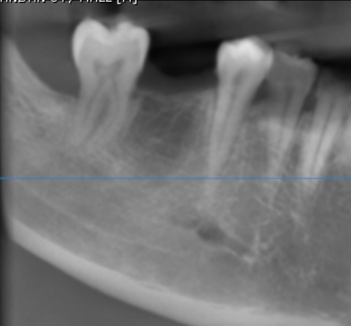

3-DIMENSIONAL VIEW

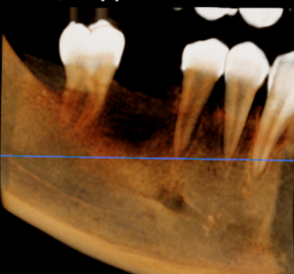

CROSS SECTIONAL VIEW

46 region | 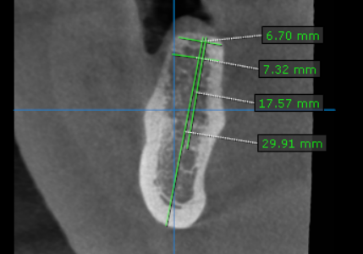

**** End of report ****

